**Name => Tanmay Bonde**

**Roll no => 33374**

**Class => TE-11**

**Batch => N-11**

**Assignment No.1-b**

Write a JavaScript Program to get the user registration data and push to array/local storage with AJAX POST method and data list in new page.

Code =>

**Backend Code**

**index.js**

const express = require("express")

app = express();

app.use(express.json());

app.use(function (req, res, next) {

// Website you wish to allow to connect

res.setHeader('Access-Control-Allow-Origin', '*');

// Request methods you wish to allow

res.setHeader('Access-Control-Allow-Methods', 'GET, POST, OPTIONS, PUT, PATCH, DELETE'); // Request headers you wish to allow

res.setHeader('Access-Control-Allow-Headers', 'X-Requested-With,content-type'); // Set to true if you need the website to include cookies in the requests sent // to the API (e.g. in case you use sessions)

res.setHeader('Access-Control-Allow-Credentials', true);

// Pass to next layer of middleware

next();

});

var data = {

firstName: "",

lastName:"",

age:"",

college:""

}

app.get("/", (req, res) => {

res.status(200).json(data);

})

app.post("/", (req, res) => {

const userData = req.body

data = userData;

console.log(data)

res.status(200).json(data);

});

app.listen(3000, () => {

console.log("http://localhost:3000")

});

**Frontend Code**

**index.html**

<!doctype html>

<html lang="en">

<head>

<title>Assignment 1B</title>

<meta charset="utf-8">

<meta name="viewport" content="width=device-width, initial-scale=1, shrink-to-fit=no"> <link href="https://cdn.jsdelivr.net/npm/bootstrap@5.2.1/dist/css/bootstrap.min.css" rel="stylesheet"

integrity="sha384-iYQeCzEYFbKjA/T2uDLTpkwGzCiq6soy8tYaI1GyVh/UjpbCx/TYkiZhlZB6+fzT" crossorigin="anonymous">

<script src="https://ajax.googleapis.com/ajax/libs/jquery/3.6.3/jquery.min.js"></script> </head>

<body>

<div class="container my-4">

<main id="output" class="bg-dark text-light p-4 rounded mb-4 w-50 mx-auto"

style="letter-spacing: 2px;">

</main>

<div class="w-50 mx-auto mb-4 text-end">

<button class="btn btn-dark" onclick="fetchData()">Reload</button>

</div>

<form id="addNumberForm" class="p-4 border shadow-sm w-50 mx-auto">

<div class="mb-2">

<label for="firstName" class="form-label">First Name</label>

<input value="sumit" type="text" class="form-control" name="firstName"

required id="firstName" aria-describedby="helpId" placeholder="Enter Your First Name"> </div>

<div class="mb-2">

<label for="lastName" class="form-label">Last Name</label>

<input value="kawale" type="text" class="form-control" name="lastName"

required id="lastName" aria-describedby="helpId" placeholder="Enter Your Last Name"> </div>

<div class="mb-2">

<label for="age" class="form-label">Age</label>

<input value="21" type="text" class="form-control" name="age" required

id="age" aria-describedby="helpId" placeholder="Enter Your Age">

</div>

<div class="mb-3">

<label for="college" class="form-label">College Name</label>

<input value="pict" type="text" class="form-control" name="college"

required id="college" aria-describedby="helpId" placeholder="Enter Your College Name"> </div>

<button type="submit" class="btn btn-primary">Submit</button>

<hr>

<small class="small text-success" id="msg"></small>

</form>

</div>

<script>

const output = document.getElementById("output");

function fetchData() {

var xhttp = new XMLHttpRequest();

xhttp.onreadystatechange = function() {

if (this.readyState == 4 && this.status == 200) {

let data = JSON.parse(xhttp.responseText)

let string = `name: ${data.firstName} ${data.lastName} <hr>age:

${data.age}<hr>college: ${data.college}`;

output.innerHTML = string;

w = window.open();

w.document.body.innerHTML = "<h1>User Details</h1><h3>";

w.document.body.innerHTML += string;

w.document.body.innerHTML += "</h3>";

}

};

xhttp.open("GET", "http://localhost:3000/", true);

xhttp.send();

}

document.body.onload = () => {

fetchData()

document.forms.addNumberForm.addEventListener("submit", (event) => {

event.preventDefault();

const firstName = event.target.firstName.value;

const lastName = event.target.lastName.value;

const age = event.target.age.value;

const college = event.target.college.value;

$("#msg").html("")

$.ajax({

type: 'post',

url: 'http://localhost:3000/',

data: JSON.stringify({

firstName, lastName, age, college

}),

contentType: "application/json; charset=utf-8",

traditional: true,

success: function(data) {

fetchData();

$("#msg").html("User Details Updated")

}

});

})

};

</script>

</body>

</html>

**Output =>**

**Input**

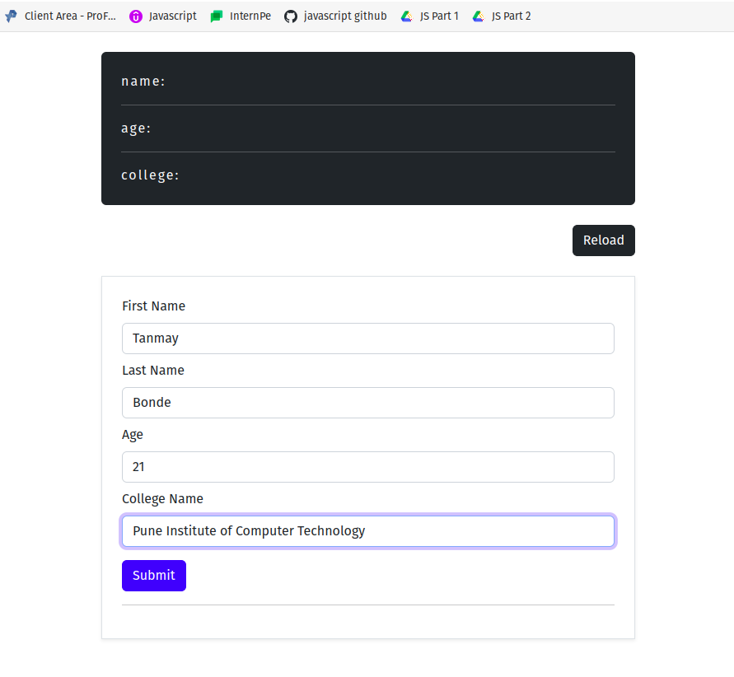

**Output**

